Student Name: Swayam UID: 25MCA20015
Branch: M.C.A Section/Group: MCA-1 A
Semester: 2 Date of Performance:12/01/2026
Subject Name: TECHINCAL SKILLS Subject Code:

AIM: To implement conditional decision-making logic in PostgreSQL using IF–ELSE constructs and CASE expressions for classification, validation, and rule-based data processing.
S/W Requirement: Oracle Database Express Edition and pgAdmin
OBJECTIVES:
- To understand conditional execution in SQL
- To implement decision-making logic using CASE expressions
- To simulate real-world rule validation scenarios
- To classify data based on multiple conditions
- To strengthen SQL logic skills required in interviews and backend systems

Practical / Experiment Steps
Step 1: Database and Table Preparation
Students should first create a table that stores:
- A unique identifier
- A schema or entity name
- A numeric count representing violations or issues
Populate the table with multiple records having different violation counts
Query:
CCREATE TABLE schema_violations (
schema_id INT PRIMARY KEY,
schema_name VARCHAR(30),
violation_count INT
);

INSERT INTO schema_violations VALUES
(1, 'Aarav', 0),
(2, 'Mehul', 2),
(3, 'Karan', 5),
(4, 'Ishita', 9),
(5, 'Nisha', 15);
select * from schema_violations

Output:
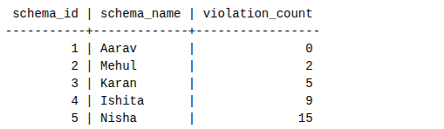

Step 2: Classifying Data Using CASE Expression
- Retrieve schema names and their violation counts.
- Use conditional logic to classify each schema into categories such as:
  - No Violation
  - Minor Violation
  - Moderate Violation
  - Critical Violation
Query:
SELECT
schema_name,
violation_count,
CASE
WHEN violation_count = 0 THEN 'No Violation'
WHEN violation_count BETWEEN 1 AND 3 THEN 'Minor Violation'
WHEN violation_count BETWEEN 4 AND 7 THEN 'Moderate Violation'
ELSE 'Critical Violation'
END AS violation_status
FROM schema_violations;

Output:
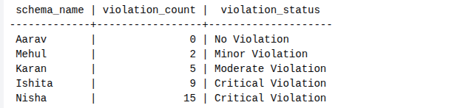

Step 3: Applying CASE Logic in Data Updates
- Add a new column to store approval status.
- Update this column based on violation count using conditional rules such as:
  - Approved
  - Needs Review
  - Rejected
Query:
ALTER TABLE schema_violations
ADD COLUMN approval_status VARCHAR(20);

UPDATE schema_violations
SET approval_status =
CASE
WHEN violation_count = 0 THEN 'Approved'
WHEN violation_count <= 5 THEN 'Needs Review'
ELSE 'Rejected'
END;

SELECT * FROM schema_violations;
Output:
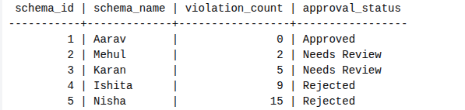

Step 4: Implementing IF–ELSE Logic Using PL/pgSQL
- Use a procedural block instead of a SELECT statement.
- Declare a variable representing violation count.
- Display different messages based on the value of the variable using IF–ELSE logic.

Query:
DO $$
DECLARE
v_count INT := 6;
BEGIN
IF v_count = 0 THEN
RAISE NOTICE 'No violations detected';
ELSIF v_count <= 5 THEN
RAISE NOTICE 'Minor violations – review required';
ELSE
RAISE NOTICE 'Critical violations – access denied';
END IF;
END $$;
Output:
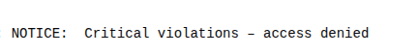

Step 5: Real-World Classification Scenario (Grading System)
- Create a table to store student names and marks.
- Classify students into grades based on their marks using conditional logic.
Query:
Step 5.1: Create Table
CREATE TABLE students (
student_id INT PRIMARY KEY,
student_name VARCHAR(30),
marks INT
);
Insert Sample Data
INSERT INTO students VALUES
(1, 'Aarav', 88),
(2, 'Mehul', 74),
(3, 'Karan', 61),
(4, 'Ishita',46),
(5, 'Nisha', 32);

Output:
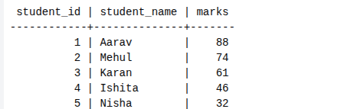
Step 5.2: Classify Students Using Conditional Logic
SELECT
student_name,
marks,
CASE
WHEN marks >= 80 THEN 'A'
WHEN marks >= 70 THEN 'B'
WHEN marks >= 60 THEN 'C'
WHEN marks >= 40 THEN 'D'
ELSE 'F'
END AS grade
FROM students;
Output:
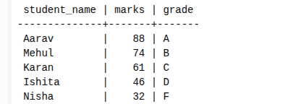

Step 6: Using CASE for Custom Sorting
- Retrieve schema details.
- Apply conditional priority while sorting records based on violation severity.
Querr:
SELECT
schema_name,
violation_count
FROM schema_violations
ORDER BY
CASE
WHEN violation_count = 0 THEN 1
WHEN violation_count <= 3 THEN 2
WHEN violation_count <= 7 THEN 3
ELSE 4
END;
Output:
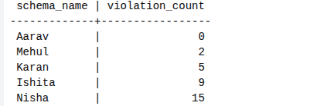

Learning Outcome:
This experiment demonstrates how conditional logic is implemented in PostgreSQL using CASE expressions and IF–ELSE constructs.
Students gain strong command over rule-based SQL logic, which is essential for:
- Backend systems
- Analytics
- Compliance reporting
- Placement and technical interviews

